

Dr. Latoya, Powell inc.

2018-08-06

Dr. Powell

7415 Carter Ridges Suite 291, Maryfurt, ME 33937

Phone: 8738670273

Fax: 6658814226

**Re:** Suzanne, Dawson

**PHN:** 8413287967

**Birthdate:** 18-Oct-1941

**Address:** 0342 Ashley Passage Suite 031, West Reginaldland, MS 05711

**Patient number:** 556140543

To Whom It May Concern:

This is a medical letter to state the above patient is pregnant with expected delivery date of 08-Feb-2025. Hoping this information is satisfactory for your requirements.

Thank you.

Sincerely,

Dr. Latoya, Powell

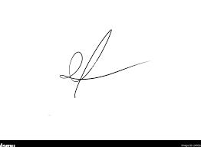

FRCS© NCMP

Clinical Assistant Professor, UBC

Department of Obstetrics and Gynecology SMH